Cairo University Data Analytics

Faculty of Computers and Artificial Intelligence Winter 2023

Operations Research and Decision Support Department Lab #1

**Lab Objectives**

* Data Types and Formatting
* Cell Referencing
* Formulas and Precedence of Operations
* Logical Functions

**Part 1**

1. Make sure your tables look like the ones shown below
   * Font “courier new” of size 14
   * Row height 22.5 and column width 21
   * Excel sheet should be named “Profits”
   * The text data “titles” must be bold, font 15, color “50 red, 85 green”, center, top align
   * Create a copy of the sheet in the same book and give it the name “copied”
   * Use 1000 separator, with no decimal places
   * Inside and outside borders
   * Apply currency format for Dell column, but make the two other companies accounting



* + Merge cells, shrink to fit, wrap text and format painter



**Part 2**

1. Create a function in the first cell, that will be dragged all over the other cells, to calculate the multiplication of each column header by each row header; as shown in the figure below

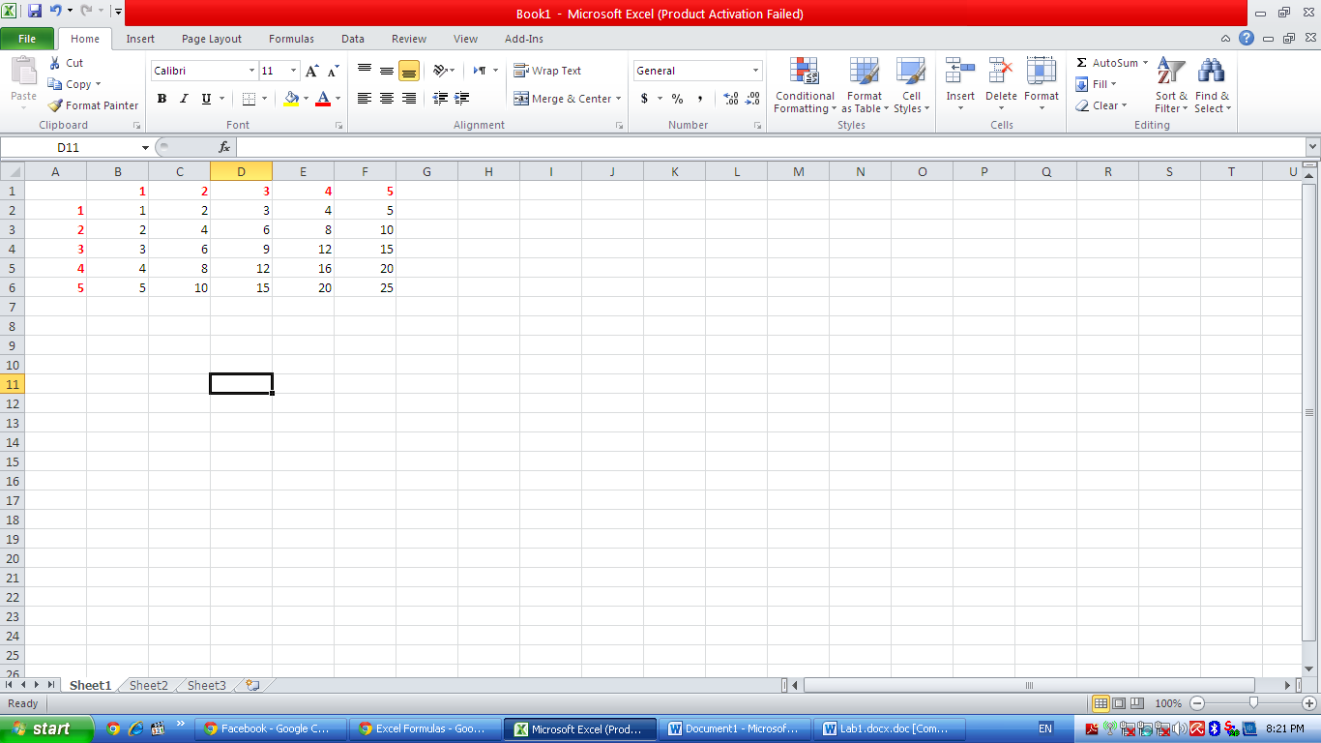

**Part 3**

1. Open a new sheet, rename it “Formulas”
2. Label column A as X and column B as Y.
3. Let X = 1,2, …,10 and Y = 2,4, …, 20
4. From column C till G name them as f1, f2, …, f5. Calculate them where:
5. f1 = 2x3 - 6x2
6. f2 = 4 * -
7. f3 = sin x + cos x
8. f4 = 3 tan2x
9. f5 = 6 log(x2+1)-x
10. Based on the results, calculate the following:
    1. Count the data values
    2. Max and Min value
    3. Range
    4. Variable Z = $\sum{\frac{X}{Y}}$

**Part 4**

1. Open the sheet named “Calculation”
   * Construct a function called “Bonus” that calculates for each salesman the amount of his bonus as follows:
2. When the income is more than or equal the min value **and** less than or equal the max value, it will multiply the bonus percentage by the income.
3. Otherwise, it will show message “No Bonus”.
   * Compute the average for the income if it is greater than 100000
   * Count the incomes that are greater than 100000.

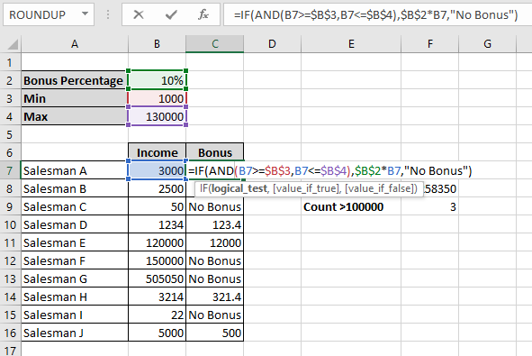

**Lab Task 1**

* + Open new sheet, name it “Fruits”, write in it the below table.
  1. Calculate the number of cells containing values greater than 50.
  2. Calculate the number of cells containing fruit type “apples” and values less than 90.
  3. Get the total number of all types of fruits

|  |  |
| --- | --- |
| **Fruit Data** | **Number Data** |
| apples | 86 |
| oranges | 54 |
| peaches | 75 |
| apples | 32 |